This statement provides you with key information about this product.
This statement is a part of the offering document.
You should not invest in this product based on this statement alone.

Quick facts
本概要提供本產品的重要資料。
本概要提供本產品的重要資料。
Fund Manager  (Authorised Corporate Director / ACD): | Threadneedle Investment Services Limited  投資經理
Investment Manager: | Threadneedle Asset Management Limited (internal delegation, UK)
Depositary: | Citibank UK Limited  Threadneedle Asset Management Limited（內部委任，英國）
Custodian | Citibank N.A.  Citibank N.
Ongoing charges over a year#: | Class 1: 1.57%
Dealing frequency: | Daily
Base currency: | GBP
Dividend policy: | Income Shares: Dividend, if declared, will be distributed twice annually
Financial year end of this Fund: | 7 March
Minimum investment: | Class 1: GBP 2,000 initial, GBP 1,000 additional
# The ongoing charges figure is based on the total asset management fee and operating expenses in accordance with the interim financial statement for the 6-month period ended 7 September 2021 and is expressed as a percentage of the average net asset value of the share class over the same period. This figure may vary from year to year.

What is this product?
本基金是甚麼產品？

Columbia Threadneedle Investment Funds (UK) ICVC – CT UK Smaller Companies Fund (the “Fund”) is a sub-fund of Columbia Threadneedle Investment Funds (UK) ICVC, an investment company (i.e. a mutual fund) with variable capital constituted in England and Wales. The home regulator of Columbia Threadneedle Investment Funds (UK) ICVC is the Financial Conduct Authority (“FCA”) in the UK.
小型公司風險

Objective and Investment Strategy

Investment Objective
The Fund aims to achieve capital growth over the long term. It looks to outperform the Numis Smaller Companies Index ex Investment Companies over rolling 3-year periods, after the deduction of charges.
本基金旨在達到長期資本增長，擬在滾存3年期間，表現在扣除開支後勝於Numis小型公司（投資公司除外）指數（Numis Smaller Companies Index ex Investment Companies）。
小型公司風險
Investment Policy
The Fund is actively managed, and invests at least 90% of its assets in the shares of companies listed on the London Stock Exchange; predominantly smaller companies traded on the Alternative Investment Market (AIM) or included within the Numis Smaller Companies Index ex Investment Companies, that are UK domiciled, or have significant UK business operations.
小型公司風險
The Fund selects companies considered to have good prospects for share price growth, from any industry or economic sector, with smaller companies providing potential exposure to niche growth areas that often cannot be accessed by large companies.
The Fund typically invests in shares of fewer than 70 companies. The Fund may invest in other securities (including fixed interest securities) and collective investment schemes (including funds managed by Columbia Threadneedle companies), when deemed appropriate.
The Fund may also hold money market instruments, deposits, cash and near cash.
The Fund is not permitted to invest in derivatives for investment purposes, but derivatives may be used with the aim of reducing risk or managing the Fund more efficiently.
The Numis Smaller Companies Index ex Investment Companies is a widely used benchmark for monitoring the performance of UK smaller companies. It consists of companies that make up the smallest 10% of the UK main listed market by value (excluding investment companies). It provides a suitable target benchmark against which Fund performance will be measured and evaluated over time.
英國主要上市公司（投資公司除外），提供一個將用作隨著時間對基金表現進行量度及評估的合適目標基準。
小型公司風險

Use of derivatives / investment in derivatives
The Fund’s net derivative exposure may be up to 50% of the Fund’s net asset value.

What are the key risks?

Investment involves risks. Please refer to the offering document for details including the risk factors.

Investment
There is no guarantee that the investment objective of the Fund can be achieved. The value of investments held by the Fund can fall as well as rise and investors might not get back the sum originally invested, especially if investments are not held for the long term.

Volatility
The price of the Fund’s investments may rise and fall sharply in the short-term and this may result in a higher volatility of the Fund’s value.

Equity Securities
The value of equity securities held by the Fund may be affected by various factors. A fall in their value will affect the price of the Fund.

Smaller Companies
小型公司風險
The Fund will invest in small cap companies. This may subject the Fund to higher volatility and liquidity risks, and greater vulnerability to fluctuations in the economic cycle.

Geographical Concentration
地域集中性風險
The Fund’s investments are concentrated in the UK. This may result in higher volatility than funds which comprise broad-based global investments.

Currency
貨幣風險
Where investments are made in assets that are denominated in multiple currencies, changes in exchange rates may affect the value of the investments.

Investor Currency
貨幣風險
Where investments in the Fund are in currencies other than your own, changes in exchange rates may affect the value of your investments.

Liquidity
The Fund invests in assets that are not always readily saleable without suffering a discount to fair value. The Fund may have to significantly lower the selling price, sell other investments or forego another, more appealing investment opportunity.

Hedge / Basis
The use of financial derivative instruments for hedging and/or efficient portfolio management purposes may become ineffective in adverse situations or if the ACD or the Investment Manager employs a strategy that does not correlate well with the Fund’s investments. This may result in a significant loss to the Fund.

How has the Fund performed?

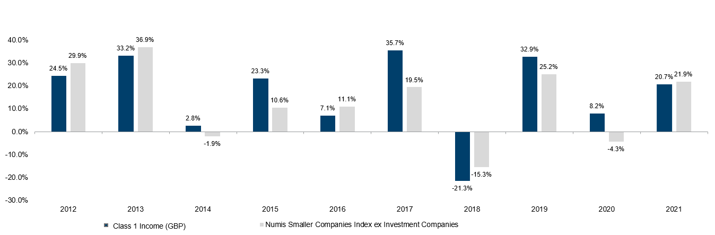

- Past performance information is not indicative of future performance. Investors may not get back the full amount invested.
- The computation basis of the performance is based on the calendar year end, NAV-To-NAV, with dividend reinvested.
- These figures show by how much the share class increased or decreased in value during the calendar year being shown. Performance data has been calculated in Euro including ongoing charges and excluding subscription fee and redemption fee you might have to pay.
- Fund launch date: 28 February 1995
- Class 1 income (GBP) launch date: 28 February 1995
- The Fund Manager views Class 1 income (GBP) shares, being the retail share class denominated in the Fund’s primary investment currency, as the most appropriate representative share class.
- The benchmark of the Fund is Numis Smaller Companies Index ex Investment Companies. Please refer to the offering document for further information relating to the benchmark.
小型公司風險
Is there any guarantee?
本基金是否提供任何保證？

This Fund does not have any guarantees. You may not get back the full amount of money you invest.

What are the fees and charges?

Charges which may be payable by you
You may have to pay the following fees when dealing in the shares of the Fund.

Fee | What you pay  您須繳付
Subscription Fee  閣下或須繳付的收費  (Initial Charge) | Class 1: Up to 5.00% of the gross amount invested
Switching Fee and Conversion Fee | Switching into shares of another fund. For the avoidance of doubt you are only permitted to switch into a fund which is authorised in Hong Kong by the SFC: Up to the prevailing initial charge for the class of shares acquired  Conversion into another class within the Fund: Nil
Redemption Fee  (Redemption Charge)  （贖回費用） | Nil

Ongoing fees payable by the Fund
The following expenses will be paid out of the Fund. They affect you because they reduce the return you get on your investments.
基金的持續費用

Annual rate
每年收費率
Management fee* | Class 1: 1.40% of the net asset value
Custodian fee | Depending on the country in which the assets are held, up to 0.44% of the assets held by the Custodian
Performance fee  表現費 | Not applicable
Administration fee*  (Ongoing registration and general expenses payable to the ACD) | Class 1: 0.15% of the net asset value
Depositary fee* | 0.01% of the net asset value
* These fees may be increased by giving at least 60 days’ notice to affected shareholders in accordance with FCA Rules.

Other fees
You may have to pay other fees when dealing in the shares of the Fund.

Additional Information
其他資料

- You generally buy and redeem shares at the Fund’s next-determined net asset value after the ACD receives your request in good order before 12 noon (UK time) on each dealing day. The Hong Kong Representative / your distributor may impose different deadlines for receiving requests from investors. Please check with your distributor regarding its internal dealing cut-off time.
- The net asset value of this Fund is calculated on each business day in England and Wales and the price of shares is published daily on the website www.columbiathreadneedle.com.
- You may obtain the past performance information of other shares offered to Hong Kong investors from www.columbiathreadneedle.com¹.

Important

If you are in doubt, you should seek professional advice.

The SFC takes no responsibility for the contents of this statement and makes no representation as to its accuracy or completeness.

The website has not been reviewed by the SFC. It may contain information on funds which are not authorised for sale to the public in Hong Kong and are not available to Hong Kong investors.

